S550 MCA Line Lock Control Function – CGEA1.3

Functional Description

Line lock is a performance feature controlled by the AdvanceTrac stability control system that allows the vehicles front brakes to be applied while the rear brakes are free (no brake pressure) without driver brake input. This feature would be initiated by the driver and allow rear wheel spin while the front brakes are holding the vehicle stationary. Traditionally, line lock is used to heat the rear tires in the burnout box and keep the vehicle stationary at the staging beams.

The Line Lock feature would be initiated and engaged through the driver's interaction with the instrument cluster LCD display and five way selection button located on the steering wheel. The stability control module would control the feature and allow entry and exit, with the cluster utilizing a status signal transmitted by the ABS module to display the status of the feature to the driver. The stability control module is responsible for checking all pre-requisites pertaining to various states of the Line Lock feature. The cluster acts only as an interface module between the user and the AdvanceTrac system via various message center displays and the 5-way switch on the steering wheel.

The Line Lock Control Function correlates the BrkLineLck_D_Stat signal, the message center 5-way switches, the vehicle configuration, and the Operational_Mode to allow the driver to initiate and engage Line Lock via a sequence of message center displays.

Interfaces

Interface Context Diagram (I/O Block Diagram)

Figure 1: Line Lock Control Function Context Diagram
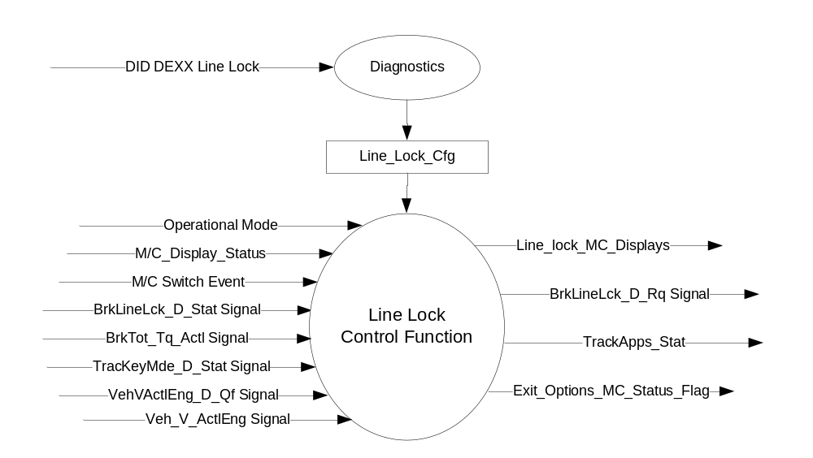

Inputs

- INTERNAL:
- Operational_Mode
- M/C_Display_Status
- M/C Switch Event
- Line_Lock_Cfg
- Current_Ign_Key_Dev_Type: Used to indicate the type of key currently in use in the vehicle. See MyKey Control Function STSS for further definition
- MUX signals on the CAN bus
- BrkLineLck_D_Stat Signal
Signal Name | Size  (bits) | Detail | Units | Res. | Offset | State  Encoded | Min | Max
BrkLineLck_D_Stat | 3 |  | SED | 1 | 0 |  | 0 (0x0) | 7 (0x7)
 |  | Available |  |  |  | 0x0
 |  | Initiated |  |  |  | 0x1
 |  | Engaged |  |  |  | 0x2
 |  | Off |  |  |  | 0x3
 |  | Not_Available |  |  |  | 0x4
 |  | Conditions Not Correct |  |  |  | 0x5
 |  | Unused |  |  |  | 0x6
 |  | Faulted |  |  |  | 0x7

- BrkTot_Tq_actl Signal
Signal Name | Size  (bits) | Detail | Units | Res. | Offset | State  Encoded | Min | Max
BrkTot_Tq_Actl | 13 |  | Nm | 4 | 0 |  | 0 (0x0) | 8189 (0x1FFD)
 |  | Unknown |  |  |  | 0x1FFE
 |  | Fault |  |  |  | 0x1FFF

- TracKeyMde_D_Stat Signal
Signal Name | Size (bits) | Detail | Units | Res. | Offset | State Encoded | Min | Max
TracKeyMde_D_Stat | 2 |  | SED | 1 | 0 |  | 0  (0x0) | 3  (0x3)
 |  | ModeNotDetermined |  |  |  | 0x0
 |  | Active |  |  |  | 0x1
 |  | NotActive |  |  |  | 0x2
 |  | NotUsed |  |  |  | 0x3

- Veh_V_ActlEng Signal
Signal Name | Size (bits) | Detail | Units | Res. | Offset | State  Encoded | Min | Max
Veh_V_ActlEng | 16 |  | KPH | 0.01 | 0 |  | -0  (0x0000) | 655.35 (0xFFFF)

- VehVActlEng_D_Qf Signal
Signal Name | Size (bits) | Detail | Units | Res. | Offset | State  Encoded | Min | Max
VehVActlEng_D_Qf | 2 |  | SED | 1 | 0 |  | 0  (0x0) | 3  (0x3)
 |  | Faulty |  |  |  | (0x0)
 |  | No_Data_Exists |  |  |  | (0x1)
 |  | Not_Within_  Specifications |  |  |  | (0x2)
 |  | OK |  |  |  | (0x3)

Outputs

- Line_Lock_MC_Displays
- TrackApps_Stat
- Exit_Options_MC_Status_Flag
- MUX signals on the CAN bus

- BrkLineLck_D_Rq Signal
Signal Name | Size  (bits) | Detail | Units | Res. | Offset | State  Encoded | Min | Max
BrkLineLck_D_Rq | 2 |  | SED | 1 | 0 |  | 0 (0x0) | 3 (0x3)
 |  | No_Request |  |  |  | 0x0
 |  | Initiate |  |  |  | 0x1
 |  | Engage |  |  |  | 0x2
 |  | Off |  |  |  | 0x3

Function/Performance

Operational Modes

Mode | Differentiating Vehicle Conditions
Sleep Mode | Line Lock Control Function Inactive
Limited Mode | Line Lock Control Function Inactive
Normal Mode | Line Lock Control Function Active / Inactive
Crank Mode | Line Lock Control Function Active / Inactive

Voltage Levels

Refer to the Cluster Features Table located in the Operational Modes and Voltage Range Strategies of this SPSS.

Human-Machine Interface

Visual

Indicator Graphics / Display Format
For High End Display (SHMI), reference HMI Specifications:
Text: Program Master Warning Message List.xls | Program Translation Table.xls
Structure: Program Menu Structure.xls

Menu Structure:

LEVEL 0 (Main Menu) | LEVEL 1 | LEVEL 2
Track Apps | Line Lock | Line Lock displays
Note: Track Apps and and subsequent items within its menu are only displayed when Track Apps is configured as Enabled.
Line Lock and subsequent displays within the Line Lock system are only displayed if Line Lock is configured as Enabled.

Indicator Color Coordinates

Reference section COLOR & ILLUMINATION REQUIREMENTS (GRAPHICS)

Indicator Characteristics

Refer to Message Center X Display_Y Button Interface Section, where X and Y are appropriate values in this document.

Audio

None.

Switch Control Logic

Consumer access to the Line Lock Control Configuration shall be as specified in the Message Center Switch – 5 Button HW Interface –CGEA 1.3 and Message Center_SHMI Displays_5 Button Interface – CGEA1.3 STSS documents.

System Accuracy

Within a 100msec of receiving a message that results in a change of state the cluster will update the display to the proper status.

Operation: Performance and Functional

Subsystem Algorithm Flowchart / State Diagram

Figure 2: Line Lock Diagnostic Configuration Flowcharts

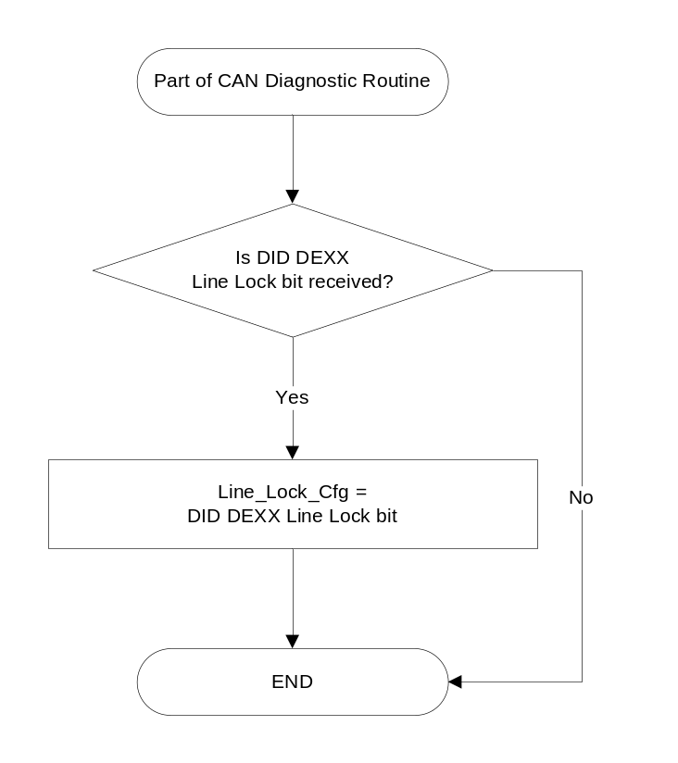

Figure 3: Line Lock Control Function
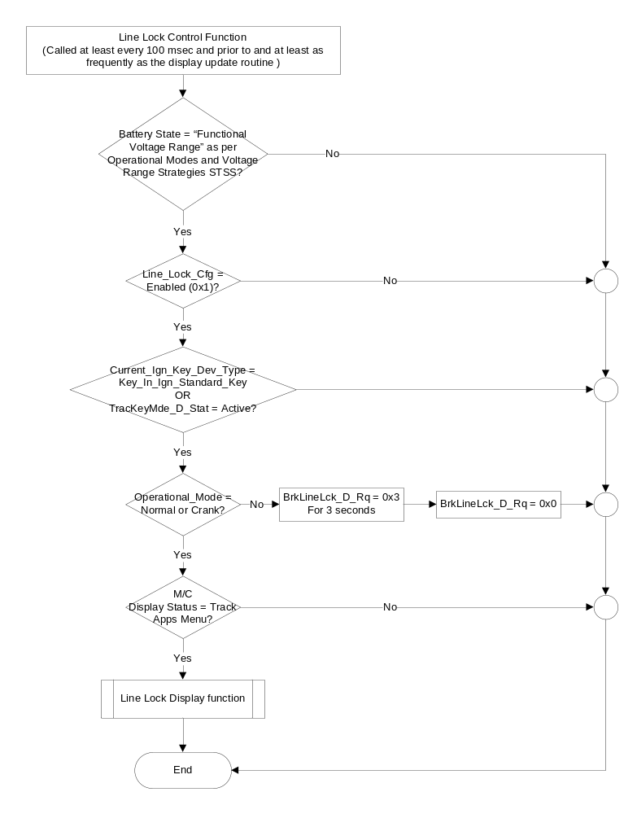

Figure 4: Line Lock Display Sub-Function

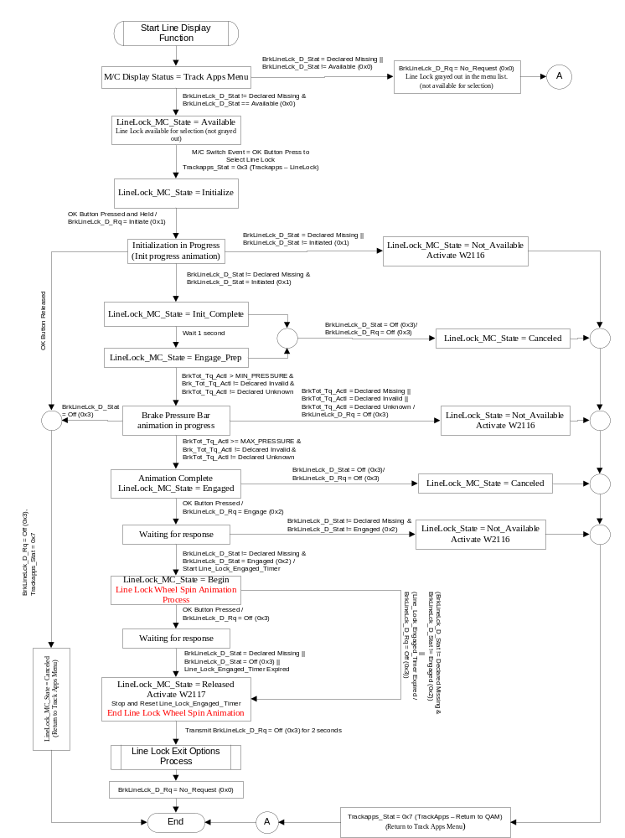
- Figure 5: Line Lock Wheel Spin Animation Process

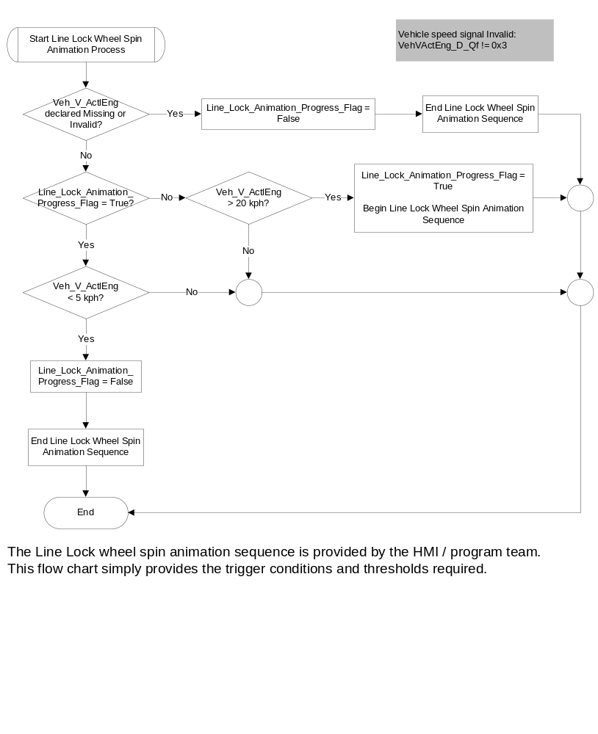

Figure 6: Line Lock Exit Options Sub-Function

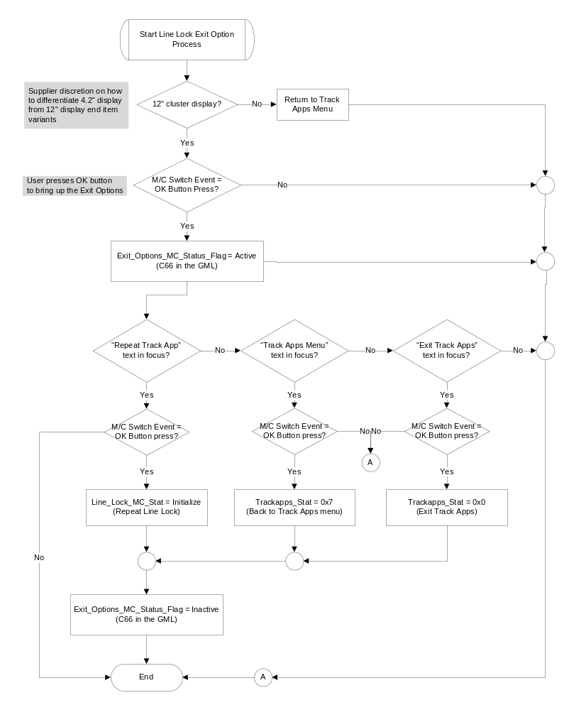

- Line Lock MC_Displays based on LineLock_Status
LineLock_MC_State | Line_Lock_MC_Displays  (example graphics)
Available | Track Apps menu with Line Lock available for selection (not grayed out)
Initialize | 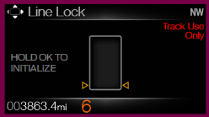
Init_Complete | 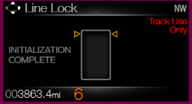
Engage_Prep | 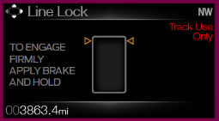
Engaged | 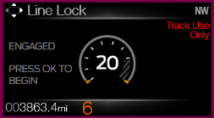
Begin | 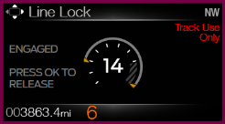
Released  W2117 | 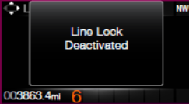
Canceled | 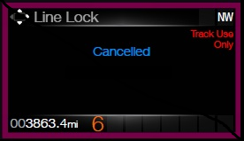
Not_Available  W2116 | 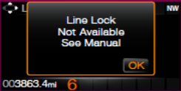

Init Progress Animation: While the user has pressed and held the OK button to initialize Line Lock, the “carrots” around the box shall start moving from bottom to the top and shall reach the top (as per graphics provided) at the end of Initialization period (2 seconds).

Brake Pressure Bar animation: Once the “Engage_Prep” state graphic is displayed, and the BrkTot_Tq_Actl > 0 Nm, the bars shall start filling up the box from bottom to top indicating increasing brake pressure. The bars are equally weighted based on the max value of the brake pressure. All the bars shall be filled up when BrkTot_Tq_Actl reaches MAX_PRESSURE value. (defined in section 1.3.5.4)

Operation Description (supports algorithm flowchart / state diagram)

- The Line Lock Control Function allows the driver to initiate, cancel, and engage/disengage the Line Lock feature through the message center via the 5-way switches.
- When in the Track Apps menu, if the cluster does not receive proper status as per figure 4 from the ABS module, the “Line Lock” item shall be grayed out. Only when cluster receives proper status from the ABS module as per figure 4 is “Line Lock” feature available to be engaged.
- The cluster is not responsible for checking any pre-conditions required to Initiate or Engage Line Lock. The ABS module is the controlling module and will do all the checks. It will then transmit appropriate status signals to which the cluster shall respond and change states on the display.
- Except for the LineLock_MC_State of “Initialize” and “Begin” stages, the user can abort the Line Lock process by pressing any of the QAM buttons or the Pony button. This will be handled in the “S550 Message Center – M3 Display with Message Center and Quick Action Menu Button Interface – CGEA 1.3” STSS for commonality purposes.
- While in the initialization screen, if the driver releases the OK button before the completion of 2 seconds, then the feature will also be canceled. However, pressing any of the QAM or Pony button will not have any effect on the cluster. The Initialization shall not be aborted.
- Once Line Lock has been successfully engaged (BrkLineLck_D_Stat = 0x2), the QAM or the Pony button press shall not have any effect on the function. QAM or the Pony button press shall not abort Line Lock during this stage.
- Once Line Lock is ON, the display shall remain active until either a) the user deactivates Line Lock by pressing OK and receiving appropriate status in return or b) Line_Lock_Engaged_Timer expires.
- The cluster shall continue to transmit the same value of the request until it changes.
- Once the cluster transmits the request signal, it shall wait 300 msec before reacting to the data received from the status signal to assure it (the cluster) does not respond to “old” data from the status signal.
- The Line_Lock_Engaged_Timer shall have a value that can be configured via a supplier DID with initial value as per section 1.3.5.4.
- The maximum value of brake pressure used in the brake pressure bar animation (MAX_PRESSURE) shall be configurable to different values via a supplier DID with initial value as per section 1.3.5.4.
- If the cluster does not receive appropriate status (includes missing signal) to the user’s request to deactivate Line Lock, the cluster shall force the Deactivate once the Line_Lock_Engaged_Timer has expired. The cluster shall turn Line Lock Off and return to the Track Apps menu as per figure 4.
- The Line Lock feature shall not be available if Line_Lock_Cfg is set to disabled (0x0).

Function Safety Classification (EMC)

B

Memory Storage

Parameter Name | Description | Value at Battery connect | Value at  Module Wake-up
M/C_Display_Status | Input to this routine that is a State Indicator to identify which text is currently being displayed on Message Center display. | See Message Center_SHMI Displays_5 Button Interface STSS | See Message Center_SHMI Displays_5 Button Interface STSS
M/C Switch Event | Event that is indicated as per the switch interface for the Message Center. See * | See * below | See * below
Line_Lock_Cfg | State Indicator for feature presence controlled via CAN at EOL at VO plant. Defaulted to Disabled at supplier manufacturing | Use Stored Value | Use Stored Value
LineLock_MC_State | Internal variable to the cluster to determine the Line Lock state and activate proper display screens. | Available | Available
BrkLineLck_D_Stat | Input CAN signal | 0x0 (Available) | 0x0 (Available)
BrkLineLck_D_Rq | Output CAN signal transmitted by the cluster. | 0x0 (No Request) | 0x0 (No Request)
BrkTot_Tq_Actl | Input CAN signal from ABS indicating brake pressure. | 0 (0x0) Nm | 0 (0x0) Nm
TracKeyMde_D_Stat signal | Input from BCM providing status of TracKey | ModeNotDetermined (0x0) | ModeNotDetermined  (0x0)
Veh_V_ActlEng | Vehicle speed as received over CAN | 0x0 | 0x0
VehVActlEng_D_Qf | Quality factor of vehicle speed as received over CAN | No_Data_Exists (0x1) | No_Data_Exists (0x1)
TrackApps_Stat | Please refer to the “Info On Demand Selection Control Function – CGEA1.3 – S550 Specific” STSS for more information.
Exit_Options_MC_Status_Flag | Output warning flag to the warning arbitrator | Inactive | Inactive
Line_Lock_Animation_  Progress_Flag | Internal flag for line lock animation based on vehicle speed triggers. | False | False
Operational_Mode | Input to this routine that is a 4 State indicator for cluster operational mode | Limited | Limited, Crank or Normal
* Refer to Message Center X Display Y Button Interface Section, where X and Y are appropriate values in this document.

Parameter Name | Description | Range | Units | Res | Init Value
Line_Lock_Engaged_Timer | Countdown Timer to keep Line Lock engaged if user does not choose to deactivate it. | 0-20 | sec | 0.1 | 15 sec

Parameter Name | Description | Range | Units | Offset | Res | Init value
MIN_PRESSURE | Minimum brake pressure required to start brake pressure bar animation | 0 –8189 | Nm | 0 | 4 | 0 Nm
MAX_PRESSURE | Max brake pressure value required to fill up all the “bars” in the animation. Max pressure is used to calculate value required for each “bar”. | 0 – 32756 | Nm | 0 | 4 | 8800 (0x0898) Nm  (Tunable value thru a supplier DID: Line_Lock_Max_  Brake_Pressure)

Prove Out

No

Reconfigurable Telltale

No

Message Center Msg

Reference displays in section 1.3.5.1 and W2116 and W2117 as per the Global message list.

Error Handling

Missing Message Strategy

The signals will be declared missing as per the Diagnostics section of this SPSS.

DTCs states and history will be determined as per the Diagnostics section of this SPSS.

If Line_Lock_Cfg is Disabled (0x0), DTC shall never be logged for this feature.

Diagnostics

Self Test

None

Engineering Test Mode

None

Part II Performance

Supported Diagnostic DIDs (Service $22 and $2E)
Number | DID / Common ID Name | DID Type | Comments / Information
$FDXX | Line_Lock_Engaged_Timer | Numeric | DID used to change the line lock engage timer value.
$FDXY | Line_Lock_Max_Brake_Pressure | Numeric | DID used to change the max value of brake pressure used in the “brake pressure bar animation”.

Supported Diagnostic Trouble Codes (DTCs)

DTC | Description
C12100 | Lost Communication with ABS_ESC

DID DEXX

Block  Num | Block Description | Byte(s) | Bits | State: Description | "0" | "1" | Default | Comments/ Information
PACKETED BLOCKS
$XX | Option Content (B&A) | * | * | Line Lock | Disable | Enable | Disable

Reference Specification

- Func. Criticality EC-0048
- Oper. Voltage Func. IS-0053
- Glare/Reflections 16-0068
- Harmony: Graphics / Font / Ill. 17-0040
- Ergo - Access. 17-0052
- Ergo - Operablility 17-0053
- Control & Display Loc. 17-0060
- Logical grouping Function and Usage 17-0062
- Assoc. of Controls with Disp. & elem. 17-0063
- Ill. Controls & Disp. 17-0074
- Id. Legibility 17-0081
- Logic of Op. 17-0120
- Interpretation 17-0122
- Feedback 17-0124

Revision History

SPSS Module Revision History
Revision Level | Name | Change Description | Date
1.0 | V. Patel | Initial Release for 2018 S550 MCA program | 3/9/2016
1.1 | V. Patel | This update is to provide logic (triggers and thresholds) required to execute the Line Lock Wheel speed animation.  Direction provided by feature owner: Keith Daugherty  - Section 1.2.1, 1.2.2: Added vehicle speed CAN signals to the input section.  - Section 1.3.5.1:  - Figure 4: Modified sequence diagram to show when the Line Lock wheel spin Animation is stopped based on timer expiration and user intervention.  - Figure 5: Developed new flowchart that starts/stops the Line Lock wheel spin animation based on vehicle speed thresholds.  - Section 1.3.5.4: Added vehicle speed CAN signal and internal flag to the memory parameters table. | 4/25/2016
1.2 | V. Patel | The incorrect CAN signal was used to trigger the Line Lock animation. This update fixes the error and defines the correct signal to be used to trigger the animation.  The speedometer signal (Veh_V_ActlEng) is the correct signal to trigger the animation. Replaced the incorrect signal with the correct signal wherever required thru out the document.  Section 1.2.1 – figure 1: Updated the context diagram to show the correct input speedometer signal. (Veh_V_ActlEng)  Section 1.2.2 – Replaced the incorrect signal definition with the correct (Veh_V_ActlEng) signal definition in tables 1.3 and 1.4  Section 1.3.5.1, figure 5: Replaced the incorrect signal with the correct signal (Veh_V_ActlEng) in the flowchart to trigger the Line Lock animation. | 7/21/2016

